'We are talking about our lifeline, not a treaty', Pakistan
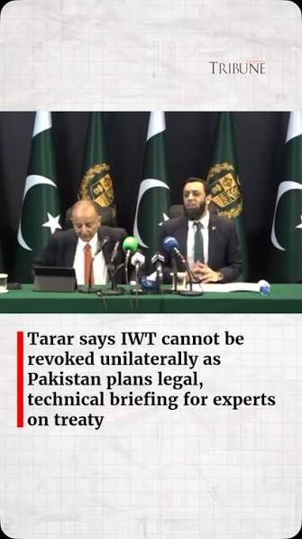
Information Minister Attaullah Tarar on Tuesday said Pakistan's 240 million people had an "inalienable right" to the waters of the Indus River, describing water as "not simply a resource, it is a matter of life itself". For over six decades, India and Pakistan have amicably managed the Indus River system through the IWT transboundary water-sharing agreement signed on September 19, 1960. Last year in April, India suspended the treaty in the wake of the Pahalgam attack.
The minister, addressing the inaugural session of an international seminar titled The Indus Waters Treaty: A Key Instrument for Peace and Regional Stability held at the Jinnah Convention Centre, said that, "We are talking about our lifeline, not a treaty," Tarar said, adding that the conference was "not merely discussing a treaty", but the lifeline of more than 240 million Pakistanis.
"As they say, water is life; the Indus has given life to Pakistan," he said.
Tarar said Pakistan's history was deeply intertwined with the Indus River, describing it as the country's lifeline and the foundation of its agriculture-based economy. He said the Indus Valley Civilisation represented Pakistan's "true identity", adding that the Indus River had sustained great civilisations for millennia and remained central to the country's heritage.
Referring to the IWT, the minister said it reflected "a historic agreement between two countries" and could not be suspended unilaterally. He added that "rivers should connect nations, not divide them". Tarar also warned against attempts to interfere with Pakistan's water resources, saying that "any attempt to divert or stop Pakistan's water would be met decisively". "The weaponisation of water undermines regional peace, stability and cooperation," he said.
"International agreements cannot be suspended or disregarded at convenience. Respect for treaties is indispensable for maintaining confidence among nations and preserving global order." Tarar said Pakistan remained committed to dialogue and the implementation of the treaty but would safeguard its water rights.
"Pakistan has consistently demonstrated its commitment to peaceful engagement and constructive dialogue," he said. "But if an attempt is made to stop the water of Pakistan, our national leadership stands resolved to respond effectively to restore the water for the people of Pakistan." Concluding his address, the minister said Pakistan would continue to pursue the issue at international forums.
"We will do all that we can at all international forums, legally and otherwise, to ensure that the right to water of the Pakistani people is protected," he said, adding that Pakistan remained "firm in its determination to protect the livelihoods and the lives of the people of Pakistan, which are linked to the Indus River".

